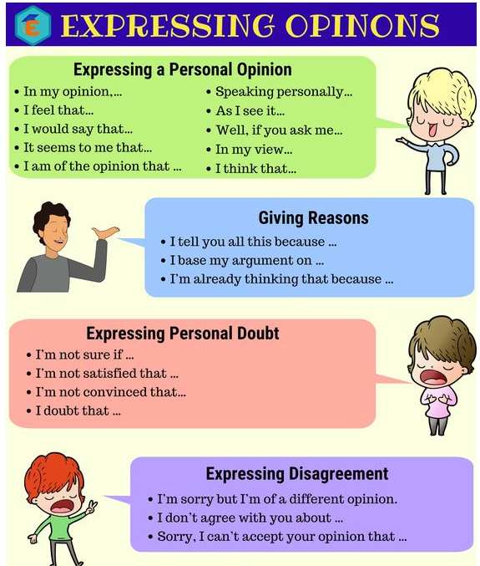

1. Based on the guide give your opinion about the following famous people. Write at least 7 sentences expressing your ideas.

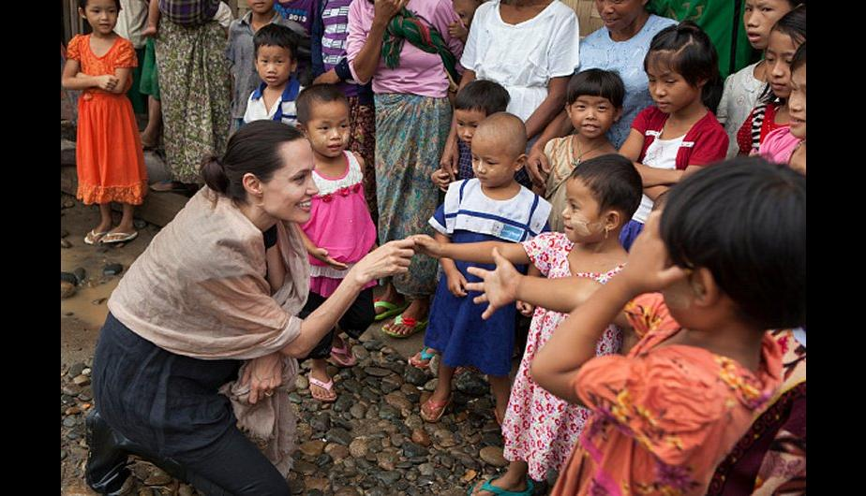

* In my opinion this woman helps children a lot

* I would say that she is a good woman

* I feel that people should be very grateful to her

* I think that she does a great job helping people

* As I see it, she would give many things to help others

* In my opinion she is a beautiful woman

* I feel that the children love her very much

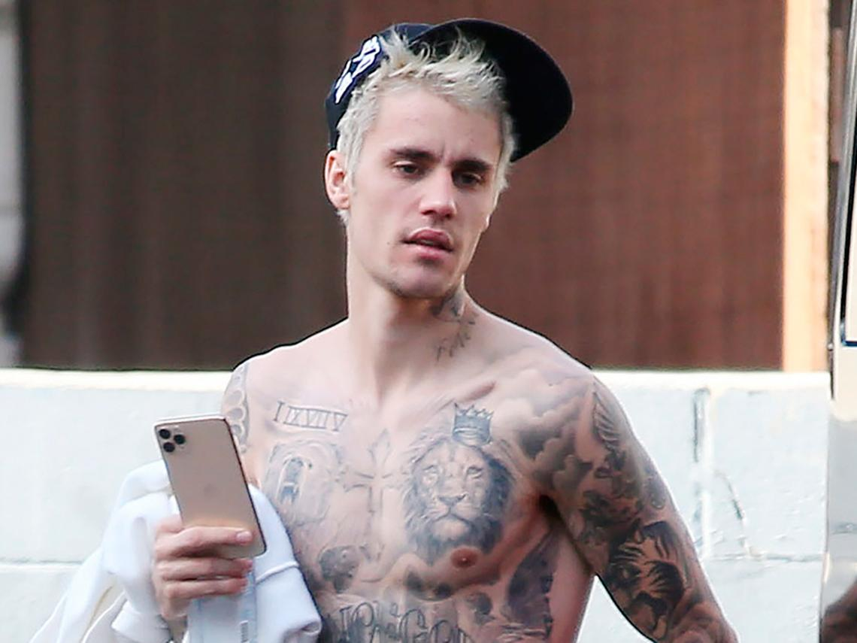

* I feel that his music does not like many people

* In my opinion I don't like his music

* I would say that he is a singer who has had many problems due to his fame

* As I see it many women are behind him

* I think you should change your lifestyle a little

* I think that his girlfriend is very pretty

* In my opinion it sings well

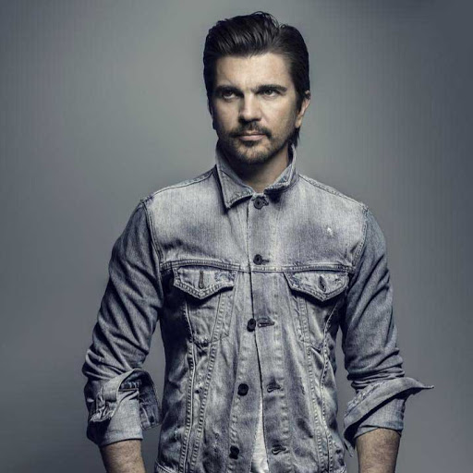

* In my opinion it has very good songs

* I would say that he is a great singer and composer

* I feel that he is a very loved artist in Colombia and many countries

* In my opinion i really like his music

* As I see it he has won many awards in his career

* In my opinion I should compose many more songs

1. Take a look of the following reading and write what do you thing about the topic. Are you agreeing with them? Where do you thing the virus started? Is China hiding information about it? ( at least 7 sentences)

### **Origins of the virus**

The coronavirus has infected more than 3.5 million people worldwide, with at least 247,000 dead. The US accounts for nearly a third of the global confirmed cases and more than one fourth of the deaths.

Pompeo's remarks followed US President Donald Trump's claims on Thursday that he had seen evidence that gave him a "high degree of confidence" the virus originated in a laboratory in Wuhan. Trump declined to provide details to back up his assertion.

Scientists in China and the West have pointed to research indicating that the virus is likely to have originated in bats and jumped to humans from an intermediate host -- just like its cousin that caused the SARS epidemic in 2002 and 2003.

The Office of the Director of National Intelligence also [said in a statement](https://www.dni.gov/index.php/newsroom/press-releases/item/2112-intelligence-community-statement-on-origins-of-covid-19) Thursday that the "Intelligence Community also concurs with the wide scientific consensus that the Covid-19 virus was not man-made or genetically modified."

[[](https://edition.cnn.com/2020/02/17/asia/china-coronavirus-xi-jinping-intl-hnk/index.html)](https://edition.cnn.com/2020/02/17/asia/china-coronavirus-xi-jinping-intl-hnk/index.html)

Asked Sunday about that conclusion, Pompeo said he has "no reason to disbelieve" the intelligence community, despite comments earlier in the same interview that "the best experts so far seem to think it was man-made. I have no reason to disbelieve that at this point."

Chinese officials and state media have repeatedly stressed that there has been no conclusion on the exact origin of the virus, while pushing their own unfounded claims alleging it did not originate in China. In March, Zhao Lijian, a spokesperson of the Chinese Foreign Ministry, [promoted a conspiracy](https://cnn.com/2020/03/13/asia/china-coronavirus-us-lijian-zhao-intl-hnk/index.html) theory on Twitter that the virus had originated in the US and was brought to China by the US military.

Taken by <https://edition.cnn.com/>

In my opinion, I believe that this virus was created in some laboratory of the countries that are mentioned, since they are countries that throughout history have been fighting in wars and for power in the world because they are world powers. They created the virus and they were in charge of spreading it around the world with this, they managed to kill many people without needing to shoot a weapon, put the world in fear of catching the virus, the economy collapsed and many more things they achieved with the virus. any of these countries results in the cure of the virus and they can distribute it to everyone and if they charge expensive for the vaccine

1. Watch the video and express your opinion about it, what do you think about that speech? Can we change that idea? Let me know what is your thoughts.

<https://www.youtube.com/watch?v=nIwU-9ZTTJc>

I think that it is a topic that currently revolves around the world a lot. I think that all people are equal and deserve the same opportunities and rights regardless of condition or gender

1. Chose two of the following topic and give your opinion.

|  |  |  |
| --- | --- | --- |
| USING ANIMALS IN MEDICAL RESEARCH HELPS PEOPLE | GAY MARRIAGES ARE WRONG | WOMEN WILL NEVER BE EQUAL TO MEN IN THE WORKPLACE |
| YOU CAN’T HAVE A HAPPY FAMILY LIFE AND A SUCCESSFUL CAREER AT THE SAME TIME | MARRIAGE IS OUTDATED | THE DEATH PENALTY IS ACCEPTABLE IN SOME CASES |
| FOREIGNERS SHOULDN’T BE ALLOWED TO VOTE | CELEBRITIES EARN TOO MUCH MONEY | MILITARY SERVICE SHOULD BE OBLIGATORY |
| WAR IS NEVER AN OPTION FOR SOLVING INTERNATIONAL DISPUTES | TORTURE CAN BE ACCEPTED IN SOME CASES | CURFEWS KEEP TEENS OUT OF TROUBLE |
| WE ARE BECOMING TOO DEPENDENT ON COMPUTERS | SMOKING SHOULD BE BANNED WORLDWIDE | SINGLE-SEX SCHOOLS ARE EVIL |

* GAY MARRIAGES ARE WRONG

I think that everyone has the right to be happy with whoever they want, regardless of what other people say, and everyone should do what they want with their life and be happy.

* MILITARY SERVICE SHOULD BE OBLIGATORY

I think it is absurd to force someone to do something they do not want, like doing military service. Many people's dreams are being frustrated by forcing them to do so.